Russell Andlauer

CS-2810-002

September 25, 2014

Assignment #4 (Chapter 3)

3.1) Gate = 1: n-type=closed, p-type=open

Gate = 0: n-type=open, p-type=closed

3.2)

P-Type

IN = 1 OUT = 0

N-Type

3.9) A B NOT(NOT(A) OR NOT(B))

0 0 0 1 1 1

0 1 0 1 1 0

1 0 0 0 1 1

1 1 1 0 0 0

An AND logic gate has the same truth table

3.10)

A B A NOR B

0 0 1

0 1 0

1 0 0

1 1 0

3.11) a) On Next Page

3.11) a)

AND

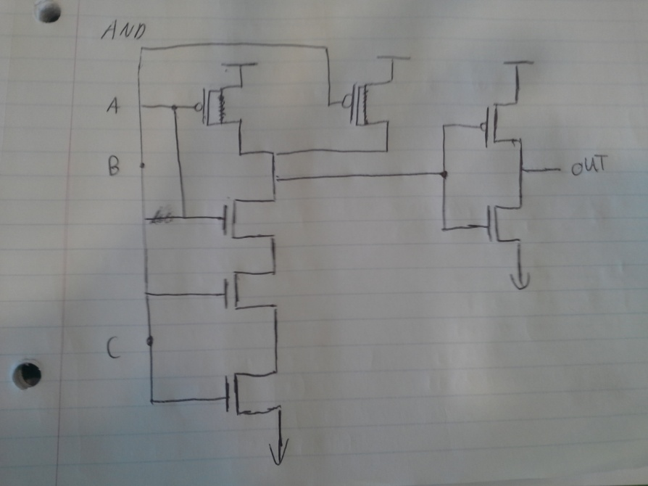

OR

